**Laser grand prix midland ILCA open meeting**

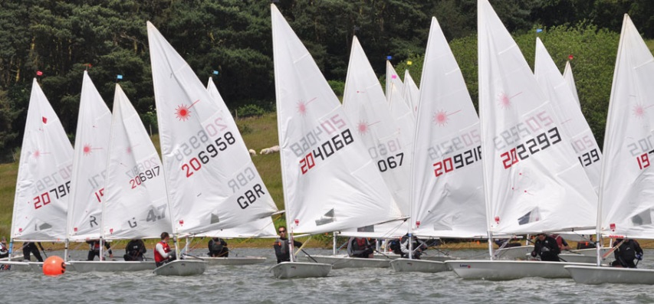at Hollowell sailing club Sunday 29 June 2025

**SCHEDULE & NOTICE OF RACE**

**Schedule:** Registration Sunday 29.June 2025 Time: 0900 - 1030. Three races, race 1 signal not before 10.55. / Lunch / race 2 & 3 ASAP after lunch.

**Biohazard Containment:** All competitors must comply with biohazard containment regulations in force by Anglian Water Authority.  The AWA website currently states, *"In accordance with Byelaw 17.2, no boat shall enter a Water Park with the intention of launching onto the water without being checked, cleaned and fully dried****before arriving****at the Water Park. Visiting boats must sign in at the point of access to confirm this process has been carried out before arriving at the park.".*

**Eligibility and Entry:** The regatta is open to all boats of the Laser Class. Boats may enter by completing the Entry Form and submitting to the entry desk on the day of the competition.

**Fees:**Entry fee £15 Lunch £3.50 (please pre-order before going on the water) or sandwiches and cakes available.

**Sailing Instruction:** Alterations to the Sailing Instructions will be displayed on Hollowell’s Race Board in the club house. Current SI's available on the club website.

**Course**: The course mentioned during the briefing may be altered by the Duty Officer when out on the water. The course to be sailed will be displayed on a board on the Committee Boat.

**Scoring:**Standard Low point system.  1 race is required to be completed to constitute a series. When 3 or fewer races have been completed, a boat’s series score will be the total of her race scores.

**Prizes**: A minimum of three places in the Open Series also first place radial and 4.7 class, first lady, first Junior, first place in the Hollowell Laser Club Championship.

**Insurance:**Each participating boat shall be insured with valid third-party liability insurance with a minimum cover of £ 2,000,000 per incident or the equivalent.

**Contact**: Further information regarding the Laser Open can be obtained from the Fleet Captain Mellissa McCullough [melissa-mccullough@hotmail.co.uk](mailto:melissa-mccullough@hotmail.co.uk) or HSC website.

Laser Grand Prix Midland ILCA

Open Meeting

At Hollowell Sailing Club

Sunday 29 June 2025

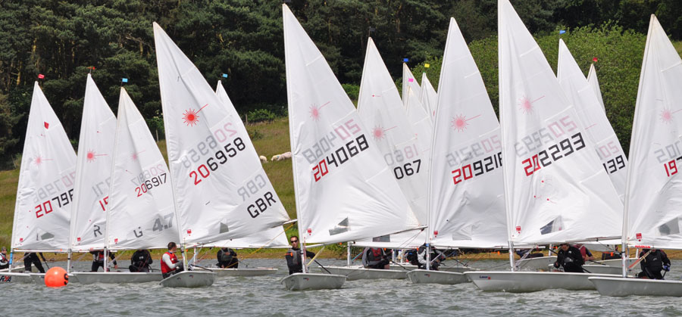

**Schedule:** Registration Sunday 29 June 2025 Time: 0900 - 1030. Three races, race 1 signal not before 10.55. / Lunch / race 2 & 3 ASAP after lunch.

**Fees:**Entry fee £15 Lunch £3.50 (please pre-order before going on the water).

**Prizes**: We have a good selection of prizes for various categories

**Come along,** doesn’t matter is you are a very good sailor or novice. **J**oin in and sail with me at the back. Hollowell is a friendly, small club and you are very welcome. You are sure to have a great day.

**Contact**: Further information regarding the Laser Open can be obtained from the Fleet Captain, Mellissa McCullough melissa-mccullough@hotmail.co.ukor Hollowell SC website.

